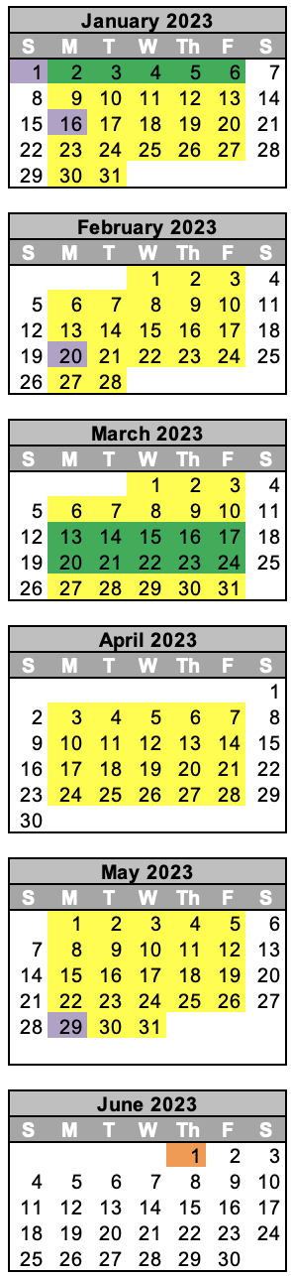
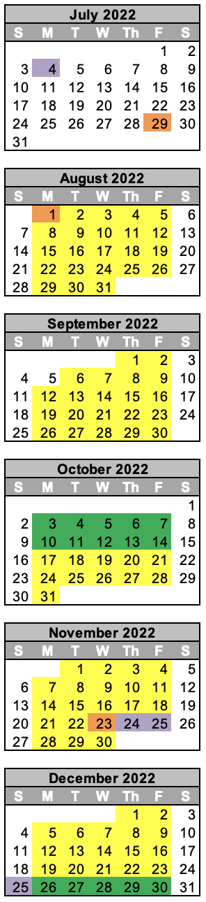
GREENFIELD-CENTRAL COMMUNITY SCHOOL CORPORATION
2022-2023 SCHOOL CALENDAR

July 29 – Teacher Work Day #1
Aug 1 - Teacher Work Day #2
Aug 2 – First Student Day
Sept 5 – Labor Day – No School
Sept 30 – Last Day of Quarter 1
Oct 3 – 14 – Fall Break
Oct 17 – First Day of Quarter 2
Nov 23 – Teacher Work Day #3
Nov 24-25 - Thanksgiving Break
Dec 23 – Last Day of Quarter 2
Dec 26-Jan 6 Winter Break
Jan 9 – First Day of Quarter 3
Jan 16 – Martin Luther King Day – No School
Feb 20 – President’s Day – No School
Mar 10 – Last Day of Quarter 3
Mar 13-24- Spring Break
Mar 27 – First Day of Quarter 4
May 29 – Memorial Day – No School
May 31 – Last Day of Quarter 4
Jun 1 - Teacher Work Day #4

Quarter 1 - Aug 2 – Sept 30 43 days
Quarter 2 - Oct 17 – Dec 23 47 days
Quarter 3 – Jan 9 – Mar 10 43 days
Quarter 4 – Mar 27 – May 31 47 days

Students/Staff in School
Teacher Work Day
Holiday
Seasonal Break

Δ In case of school closings due to inclement weather or emergency conditions, make-up days will be designated by the superintendent and may include available teacher work days, holidays, seasonal breaks or days beyond the last student day.

